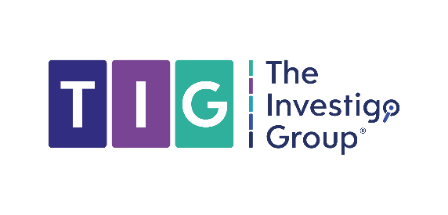
Subject Access Request

The Investigo Group Limited
Unit 116 Imperial Court
Exchange Street East
Liverpool
England
L2 3AB

[Date]

Subject: Subject Access Request under UK GDPR
Dear Sir/Madam,
I am writing to make a Subject Access Request under Article 15 of the UK General Data Protection Regulation and section 45 of the Data Protection Act 2018.
Please provide me with:

1. Confirmation of whether you are processing my personal data
2. A copy of all personal data you hold about me
3. Information about the purposes of processing
4. The categories of personal data concerned
5. The recipients to whom my data has been disclosed
6. The retention period for my data
7. Information about the source of any data not collected from me directly

My details for identification purposes:

Full name: [YOUR FULL NAME]
Address: [YOUR ADDRESS]
Date of birth: [YOUR DATE OF BIRTH]
Email: [YOUR EMAIL ADDRESS]
[Any account numbers, reference numbers, or other identifiers: [REFERENCE NUMBER]]

I enclose a copy of [my passport/driving licence] to verify my identity.

Under UK GDPR, you must respond to this request within one calendar month.

Please confirm receipt of this request.

Yours sincerely,

Name
Title

Email:

